UNIT-IV
Memory Hierarchy Design and its Characteristics
In the Computer System Design, Memory Hierarchy is an enhancement to organize the memory such that it can minimize the access time. The Memory Hierarchy was developed based on a program behavior known as locality of references.The figure below clearly demonstrates the different levels of memory hierarchy :
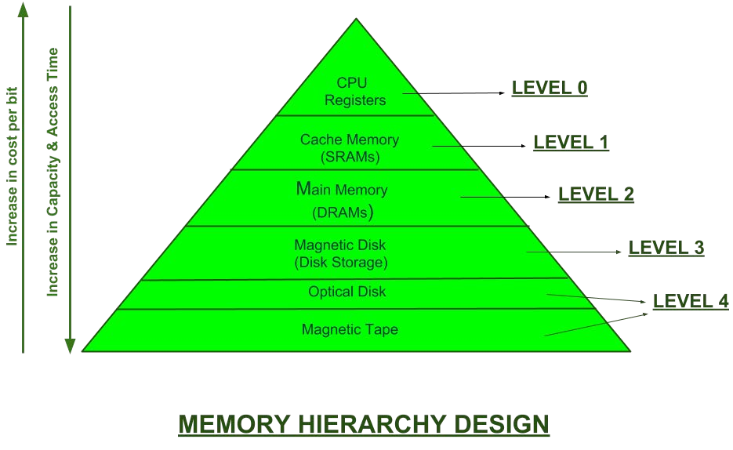
This Memory Hierarchy Design is divided into 2 main types:
- External Memory or Secondary Memory –Comprising of Magnetic Disk, Optical Disk, Magnetic Tape i.e. peripheral storage devices which are accessible by the processor via I/O Module.
- Internal Memory or Primary Memory –Comprising of Main Memory, Cache Memory & CPU registers. This is directly accessible by the processor.
We can infer the following characteristics of Memory Hierarchy Design from above figure:

Capacity:
It is the global volume of information the memory can store. As we move from top to bottom in the Hierarchy, the capacity increases.

Access Time:
It is the time interval between the read/write request and the availability of the data. As we move from top to bottom in the Hierarchy, the access time increases.

Performance:
Earlier when the computer system was designed without Memory Hierarchy design, the speed gap increases between the CPU registers and Main Memory due to large difference in access time. This results in lower performance of the system and thus, enhancement was required. This enhancement was made in the form of Memory Hierarchy Design because of which the performance of the system increases. One of the most significant ways to increase system performance is minimizing how far down the memory hierarchy one has to go to manipulate data.

Cost per bit:
As we move from bottom to top in the Hierarchy, the cost per bit increases i.e. Internal Memory is costlier than External Memory.

RAM and ROM architecture.
- Read-only memory, or ROM, is a form of data storage in computers and other electronic devices that cannot be easily altered or reprogrammed. RAM is referred to as volatile memory and is lost when the power is turned off whereas ROM in non-volatile and the contents are retained even after the power is switched off.
Types of ROM: Semiconductor-Based
Classic mask-programmed ROM chips are integrated circuits that physically encode the data to be stored, and thus it is impossible to change their contents after fabrication. Other types of non-volatile solid-state memory permit some degree of modification:
  - Programmable read-only memory (PROM), or one-time programmable ROM (OTP), can be written to or programmed via a special device called a PROM programmer. Typically, this device uses high voltages to permanently destroy or create internal links (fuses or antifuses) within the chip. Consequently, a PROM can only be programmed once.
  - Erasable programmable read-only memory (EPROM) can be erased by exposure to strong ultraviolet light (typically for 10 minutes or longer), then rewritten with a process that again needs higher than usual voltage applied. Repeated exposure to UV light will eventually wear out an EPROM, but the endurance of most EPROM chips exceeds 1000 cycles of erasing and reprogramming. EPROM chip packages can often be identified by the prominent quartz "window" which allows UV light to enter. After programming, the window is typically covered with a label to prevent accidental erasure. Some EPROM chips are factory-erased before they are packaged, and include no window; these are effectively PROM.
  - Electrically erasable programmable read-only memory (EEPROM) is based on a similar semiconductor structure to EPROM, but allows its entire contents (or selected banks) to be electrically erased, then rewritten electrically, so that they need not be removed from the computer (whether general-purpose or an embedded computer in a camera, MP3 player, etc.). Writing or flashing an EEPROM is much slower (milliseconds per bit) than reading from a ROM or writing to a RAM (nanoseconds in both cases).
  - Electrically alterable read-only memory (EAROM) is a type of EEPROM that can be modified one bit at a time. Writing is a very slow process and again needs higher voltage (usually around 12 V) than is used for read access. EAROMs are intended for applications that require infrequent and only partial rewriting. EAROM may be used as non-volatile storage for critical system setup information; in many applications, EAROM has been supplanted by CMOS RAM supplied by mains power and backed-up with a lithium battery.
  - Flash memory (or simply flash) is a modern type of EEPROM invented in 1984. Flash memory can be erased and rewritten faster than ordinary EEPROM, and newer designs feature very high endurance (exceeding 1,000,000 cycles). Modern NAND flash makes efficient use of silicon chip area, resulting in individual ICs with a capacity as high as 32 GB as of 2007; this feature, along with its endurance and physical durability, has allowed NAND flash to replace magnetic in some applications (such as USB flash drives). Flash memory is sometimes called flash ROM or flash EEPROM when used as a replacement for older ROM types, but not in applications that take advantage of its ability to be modified quickly and frequently.
- Random-access memory, or RAM, is a form of data storage that can be accessed randomly at any time, in any order and from any physical location in contrast to other storage devices, such as hard drives, where the physical location

of the data determines the time taken to retrieve it. RAM is measured in megabytes and the speed is measured in nanoseconds and RAM chips can read data faster than ROM.
Types of RAM: The two widely used forms of modern RAM are static RAM (SRAM) and dynamic RAM (DRAM). In SRAM, a bit of data is stored using the state of a six transistor memory cell. This form of RAM is more expensive to produce, but is generally faster and requires less dynamic power than DRAM. In modern computers, SRAM is often used as cache memory for the CPU. DRAM stores a bit of data using a transistor and capacitor pair, which together comprise a DRAM cell. The capacitor holds a high or low charge (1 or 0, respectively), and the transistor acts as a switch that lets the control circuitry on the chip read the capacitor's state of charge or change it. As this form of memory is less expensive to produce than static RAM, it is the predominant form of computer memory used in modern computers. The figure below shows DRAM & SRAM resp.
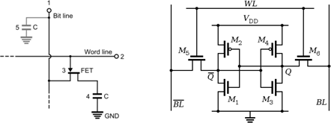
Both static and dynamic RAM are considered volatile, as their state is lost or reset when power is removed from the system. By contrast, read-only memory (ROM) stores data by permanently enabling or disabling selected transistors, such that the memory cannot be altered. Writeable variants of ROM (such as EEPROM and flash memory) share properties of both ROM and RAM, enabling data to persist without power and to be updated without requiring special equipment. These persistent forms of semiconductor ROM include USB flash drives, memory cards for cameras and portable devices, and solid-state drives. ECC memory (which can be either SRAM or DRAM) includes special circuitry to detect and/or correct random faults (memory errors) in the stored data, using parity bits or error correction codes.
In general, the term RAM refers solely to solid-state memory devices (either DRAM or SRAM), and more specifically the main memory in most computers. In optical storage, the term DVD-RAM is somewhat of a misnomer since, unlike CD- RW or DVD-RW it does not need to be erased before reuse. Nevertheless, a DVD- RAM behaves much like a hard disc drive if somewhat slower.

Difference between Static Ram And Dynamic Ram
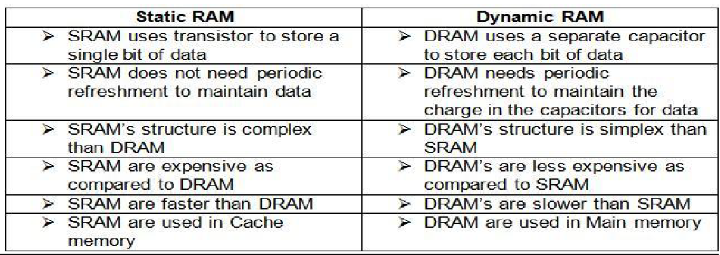

Requirements of Memory Management System
Memory management keeps track of the status of each memory location, whether it is allocated or free. It allocates the memory dynamically to the programs at their request and frees it for reuse when it is no longer needed. Memory management meant to satisfy some requirements that we should keep in mind.
These Requirements of memory management are:
- Relocation – The available memory is generally shared among a number of processes in a multiprogramming system, so it is not possible to know in advance which other programs will be resident in main memory at the time of execution of his program. Swapping the active processes in and out of the main memory enables the operating system to have a larger pool of ready-to-execute process.

When a program gets swapped out to a disk memory, then it is not always possible that when it is swapped back into main memory then it occupies the previous memory location, since the location may still be occupied by another process. We may need to relocate the process to a different area of memory. Thus there is a possibility that program may be moved in main memory due to swapping.
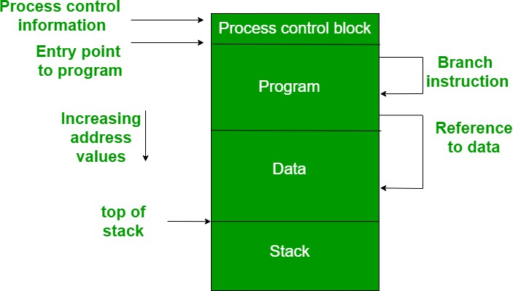
The figure depicts a process image. The process image is occupying a continuous region of main memory. The operating system will need to know many things including the location of process control information, the execution stack, and the code entry. Within a program, there are memory references in various instructions and these are called logical addresses.
After loading of the program into main memory, the processor and the operating system must be able to translate logical addresses into physical addresses. Branch instructions contain the address of the next instruction to be executed. Data reference instructions contain the address of byte or word of data referenced.
- Protection – There is always a danger when we have multiple programs at the same time as one program may write to the address space of another program. So every process must be protected against unwanted interference when other process tries to write in a process whether accidental or incidental. Between relocation and protection requirement a trade-off occurs as the satisfaction of

relocation requirement increases the difficulty of satisfying the protection requirement.
Prediction of the location of a program in main memory is not possible, that’s why it is impossible to check the absolute address at compile time to assure protection. Most of the programming language allows the dynamic calculation of address at run time. The memory protection requirement must be satisfied by the processor rather than the operating system because the operating system can hardly control a process when it occupies the processor. Thus it is possible to check the validity of memory references.

- Sharing – A protection mechanism must have to allow several processes to access the same portion of main memory. Allowing each processes access to the same copy of the program rather than have their own separate copy has an advantage.
For example, multiple processes may use the same system file and it is natural to load one copy of the file in main memory and let it shared by those processes. It is the task of Memory management to allow controlled access to the shared areas of memory without compromising the protection. Mechanisms are used to support relocation supported sharing capabilities.

- Logical organization – Main memory is organized as linear or it can be a one- dimensional address space which consists of a sequence of bytes or words. Most of the programs can be organized into modules, some of those are unmodifiable (read-only, execute only) and some of those contain data that can be modified. To effectively deal with a user program, the operating system and computer hardware must support a basic module to provide the required protection and sharing. It has the following advantages:

  - Modules are written and compiled independently and all the references from one module to another module are resolved by `the system at run time.
  - Different modules are provided with different degrees of protection.
  - There are mechanisms by which modules can be shared among processes. Sharing can be provided on a module level that lets the user specify the sharing that is desired.

- Physical organization – The structure of computer memory has two levels referred to as main memory and secondary memory. Main memory is relatively very fast and costly as compared to the secondary memory. Main memory is volatile. Thus secondary memory is provided for storage of data on a long-term basis while the main memory holds currently used programs. The major system concern between main memory and secondary memory is the flow of information and it is impractical for programmers to understand this for two reasons:

  - The programmer may engage in a practice known as overlaying when the main memory available for a program and its data may be insufficient. It allows different modules to be assigned to the same region of memory. One disadvantage is that it is time-consuming for the programmer.
  - In a multiprogramming environment, the programmer does not know how much space will be available at the time of coding and where that space will be located inside the memory.

Cache Memory in Computer Organization
Cache Memory is a special very high-speed memory. It is used to speed up and synchronizing with high-speed CPU. Cache memory is costlier than main memory or disk memory but economical than CPU registers. Cache memory is an extremely fast memory type that acts as a buffer between RAM and the CPU. It holds frequently requested data and instructions so that they are immediately available to the CPU when needed.
Cache memory is used to reduce the average time to access data from the Main memory. The cache is a smaller and faster memory which stores copies of the data from frequently used main memory locations. There are various different independent caches in a CPU, which store instructions and data.
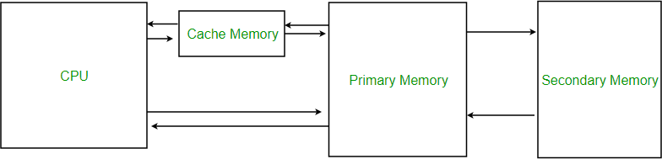

Levels of memory:
- Level 1 or Register – It is a type of memory in which data is stored and accepted that are immediately stored in CPU. Most commonly used register is accumulator, Program counter, address register etc.
- Level 2 or Cache memory – It is the fastest memory which has faster access time where data is temporarily stored for faster access.
- Level 3 or Main Memory – It is memory on which computer works currently. It is small in size and once power is off data no longer stays in this memory.
- Level 4 or Secondary Memory – It is external memory which is not as fast as main memory but data stays permanently in this memory.

Cache Performance:
When the processor needs to read or write a location in main memory, it first checks for a corresponding entry in the cache.
- If the processor finds that the memory location is in the cache, a cache hit has occurred and data is read from cache
- If the processor does not find the memory location in the cache, a cache miss has occurred. For a cache miss, the cache allocates a new entry and copies in data from main memory, then the request is fulfilled from the contents of the cache.

The performance of cache memory is frequently measured in terms of a quantity called Hit ratio.
Hit ratio = hit / (hit + miss) = no. of hits/total accesses
We can improve Cache performance using higher cache block size, higher associativity, reduce miss rate, reduce miss penalty, and reduce Reduce the time to hit in the cache.

Application of Cache Memory –
- Usually, the cache memory can store a reasonable number of blocks at any given time, but this number is small compared to the total number of blocks in the main memory.
- The correspondence between the main memory blocks and those in the cache is specified by a mapping function.

Types of Cache –
  - Primary Cache – A primary cache is always located on the processor chip. This cache is small and its access time is comparable to that of processor registers.
  - Secondary Cache – Secondary cache is placed between the primary cache and the rest of the memory. It is referred to as the level 2 (L2) cache. Often, the Level 2 cache is also housed on the processor chip.

Locality of reference – Since size of cache memory is less as compared to main memory. So to check which part of main memory should be given priority and loaded in cache is decided based on locality of reference.

Types of Locality of reference
Spatial Locality of reference This says that there is a chance that element will be present in the close proximity to the reference point and next time if again searched then more close proximity to the point of reference.
Temporal Locality of reference In this Least recently used algorithm will be used. Whenever there is page fault occurs within a word will not only load word in main memory but complete page fault will be loaded because spatial locality of reference rule says that if you are referring any word next word will be referred in its register that’s why we load complete page table so the complete block will be loaded.

